**Post 1:**

🌟 Exciting News! 🌟 United Way of Northern Arizona has kicked off the 2023 campaign! 🚀

Their mission is clear: Mobilize communities in Coconino, Navajo, and Apache counties to Step Up for Our Youth.

When we do, we can tackle the big challenges in early childhood development and positive youth growth, ensuring a brighter future for our young ones.

UWNA is also committed to meeting the fundamental needs of safety and security for all who call this place home. 🏠 With support from all of us, we can direct resources swiftly and efficiently to where they're needed most. ⏩

I’m a supporter of this year’s campaign and I’d love for you to join me!

Together, we can be United in Purpose: <https://andar.nazunitedway.org/comm/SinglePageRegPledge.jsp?SA=305813>

#UnitedInPurpose #StrongerCommunity #BetterFuture #NorthernArizonaCommunity #StepUpForYouth #TogetherWeCanDoMore

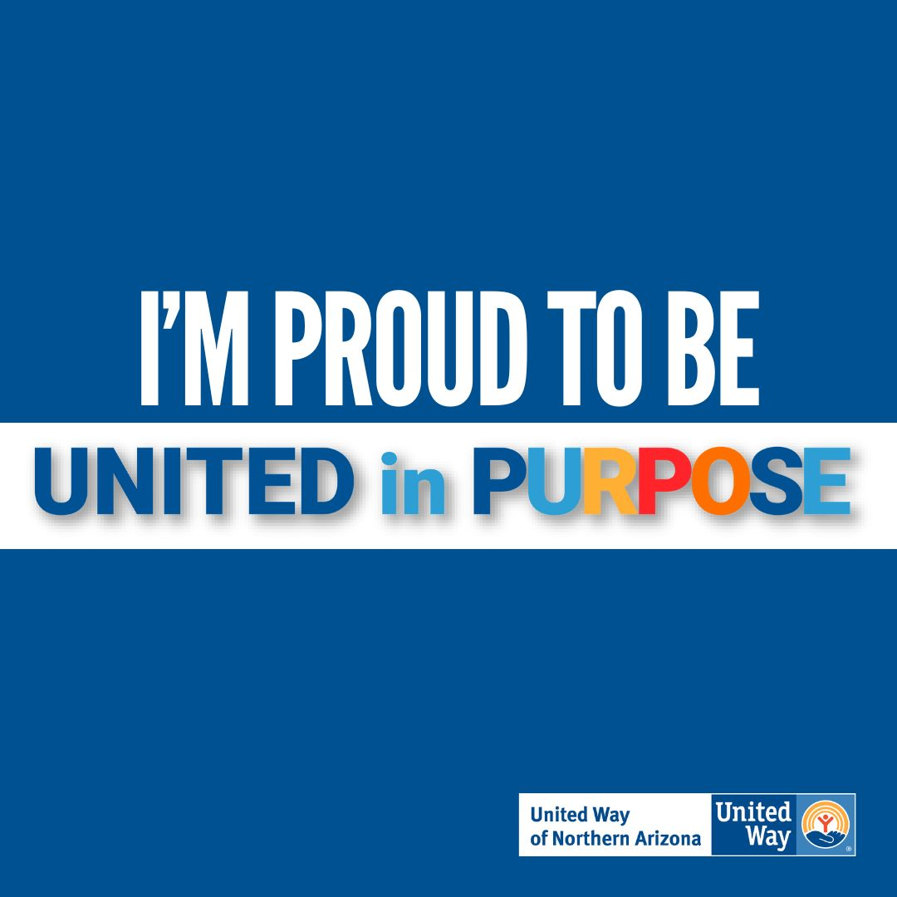

**Post 2:**

Did you know that United Way of Northern Arizona has officially kicked off their 2023 Campaign? ✨

It’s all about being United in Purpose 🙌🏽

I’m a supporter of UWNA and I’d love for your to join me, too!

This year, campaign success is being measured not only in the total number of dollars raised but also but also by the number of first-time donors.

Together we can improve lives of all of those in need in our community. Will you join me?

Click here to donate today: <https://andar.nazunitedway.org/comm/SinglePageRegPledge.jsp?SA=305813>

Thank you for being United in Purpose 💪🏼

#UnitedInPurpose #StrongerCommunity #BetterFuture #NorthernArizonaCommunity #StepUpForYouth #TogetherWeCanDoMore

