Post 1:
United Way of Northern Arizona’s mission is clear: Mobilize communities in Coconino, Navajo, and Apache counties to Step Up for Our Youth.

When we do, we can tackle the big challenges in early childhood development and making sure our youth grow to be resilient, ensuring a brighter future for all.

UWNA is also committed to meeting the fundamental needs of safety and security for all who call northern Arizona home. 🏠 With support from all of us, we can direct resources swiftly and efficiently to where they're needed most. ⏩

I’m a supporter of this year’s campaign and I’d love for you to join me!

Together, we can be United in Purpose: https://andar.nazunitedway.org/comm/SinglePageRegPledge.jsp?SA=305813

#UnitedInPurpose #StrongerCommunity #BetterFuture #NorthernArizonaCommunity #StepUpForYouth #TogetherWeCanDoMore

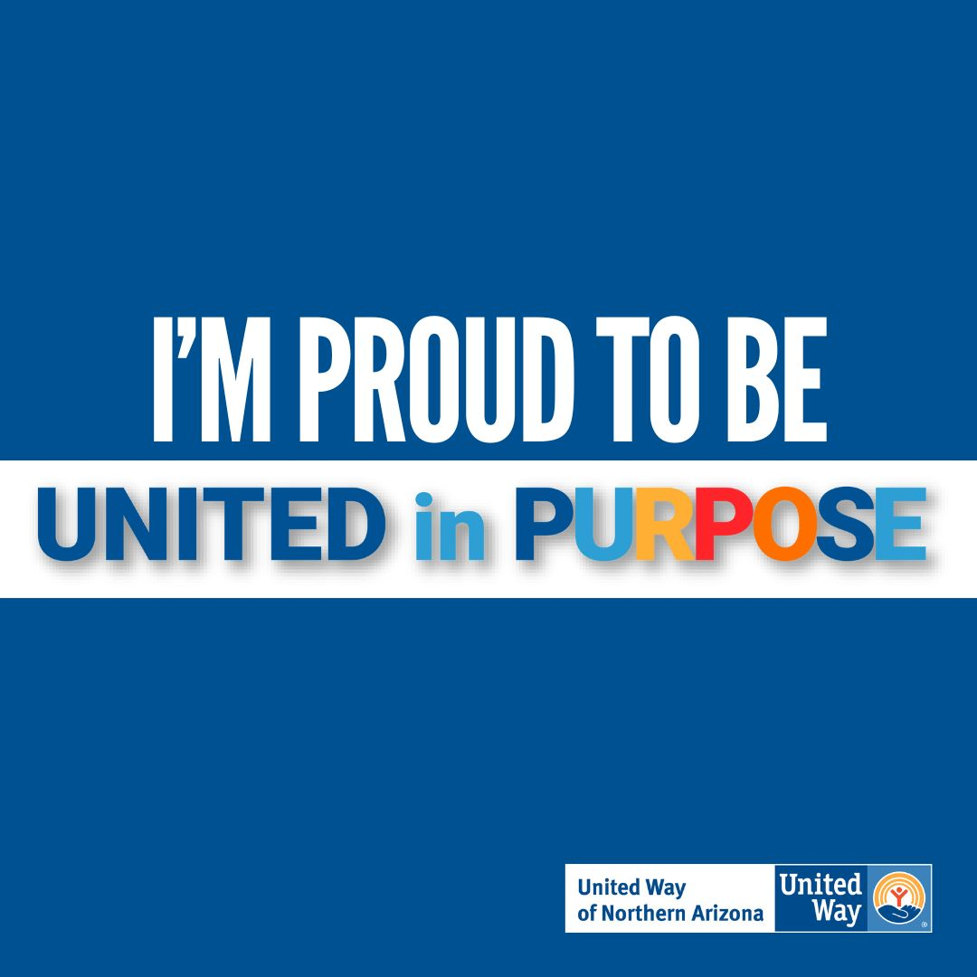

Post 2:
United Way of Northern Arizona’s 2023-2024 annual campaign is going on now! ✨

It’s all about being United in Purpose 🙌🏽

I’m a supporter of UWNA and I’d love for you to join me, too!

This year, campaign success is being measured not only in the total number of dollars raised but also but also by the number of first-time donors.

Together we can improve the lives of all of those in need in our community. Will you join me?

Click here to donate today: https://andar.nazunitedway.org/comm/SinglePageRegPledge.jsp?SA=305813
Thank you for being United in Purpose 💪🏼

#UnitedInPurpose #StrongerCommunity #BetterFuture #NorthernArizonaCommunity #StepUpForYouth #TogetherWeCanDoMore

