WORKPLACE CAMPAIGN EMAIL SEQUENCE
Below are a few email templates to help your Campaign Coordinator communicate with your employees. Please modify them to fit your workplace.

EMAIL 1A

CEO Email Prior to Kickoff
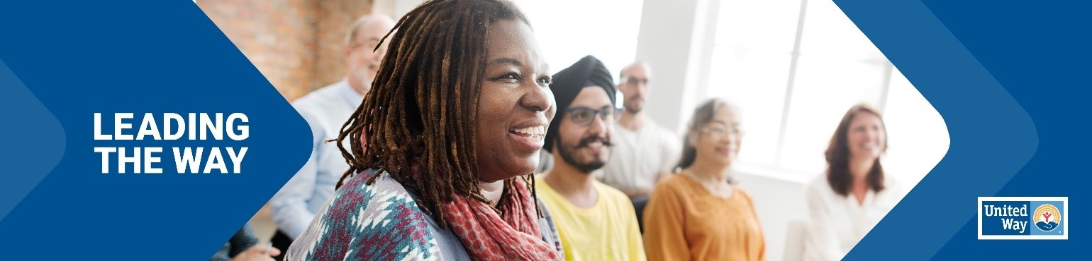
[Subject Line]
Be a Force for Change

Dear [COMPANY] colleagues,

Together, we are Leading the Way and working to step up for our youth and our communities in northern Arizona.

Because of you, United Way of Northern Arizona can convene our leaders to ensure that the right partners and resources are brought together in a collaborative way to create a more equitable and thriving community for us all.

When you give your dollars or time, you help fund programs that promote:
- Early Childhood Development, like KinderCamp™ or the Dolly Parton Imagination Library,
- Positive Youth Development, such as mentoring programs, and
- Basic Safety and Security for families or communities in crisis.

Learn more about the work of United Way of Northern Arizona and how you can be Lead the Way, by visiting www.nazunited.org.

We invite you to attend our campaign kick-off meeting on [DATE] at [LOCATION] to learn more about our giving campaign and how the work of United Way makes an impact in our community.
If you have any questions any time throughout the campaign, please reach out to [Campaign Coordinator NAME + EMAIL].

Thank you!
[CEO NAME]

*************************

[Subject Line] United Way Campaign Launch: Leading the Way

Hello [COMPANY] Employees!

Today, we come together to kick off our [COMPANY] United Way campaign. TOGETHER, in our collaborative journey to improve the lives of children, families and individuals throughout Coconino, Navajo, and Apache counties.
Join us at our [EVENT – POTLUCK, ICE CREAM SOCIAL, ETC.] today in [LOCATION: ONLINE / IN-PERSON] at [TIME] to learn about our partnership with United Way and what that means for northern Arizona.

See you there!
[COORDINATOR SIGNATURE AND CONTACT INFO]

****************************************

EMAIL 1B

[Subject Line] Acting Today for a Better Tomorrow

Good [Morning/Afternoon COMPANY] Team,

United Way of Northern Arizona mobilizes our community, so our youth are supported from cradle to career, and families are helped in times of crisis.

They work with our community, corporate, and nonprofit partners to achieve bold goals for northern Arizona. Your support goes to the most effective programs supporting our neighbors.
With your continued support, we will:
• Feed those facing food insecurity
• House those experiencing homelessness
• Help students stay in school
• Prepare youth for success in school, work and life
• Support emergency shelters and homelessness prevention
• Connect those in financial distress with resources to pay bills and stay in their homes
and so much more!

As a reminder, our United Way campaign kicked off on [DAY OF WEEK & DATE]. Our goal is to [raise $$$ OR reach %%% participation] by the end of our campaign on [DATE].
Feel free to reach out to me with any questions about your donation, or to seek out volunteer opportunities!

[COORDINATOR SIGNATURE AND CONTACT INFO]

*****************************

EMAIL 2

[Subject Line] Leading the Way is Up to Us!
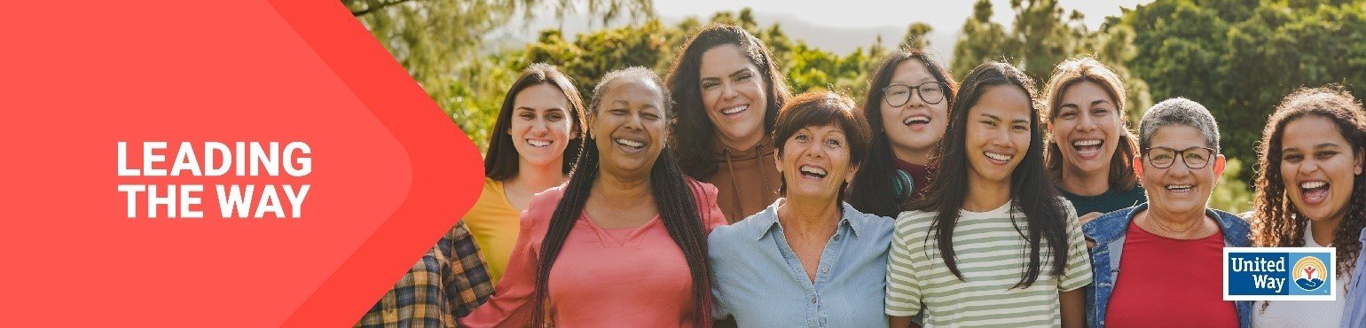
Good [Morning/Afternoon COMPANY] Team,

Lead the Way for our community means kicking down old barriers and championing new ways of thinking.

Our [COMPANY] United Way campaign is an essential part of those efforts. Together, we play a role in creating solutions, opportunities and positive change for our neighbors. Your contribution to this campaign helps United Way continue to promote:

- Early Childhood Development
- Positive Youth Development, and
- Safety and Security for all who live in Coconino, Navajo, and Apache counties.

We are [$$$ *OR %%%] away from our goal of [$$$ *OR %%% participation] by the end of our campaign on [DATE].

Feel free to reach out to me with any questions!

[COORDINATOR SIGNATURE AND CONTACT INFO]

************************************

EMAIL 3
[Subject Line] Your Donation Makes a Difference!
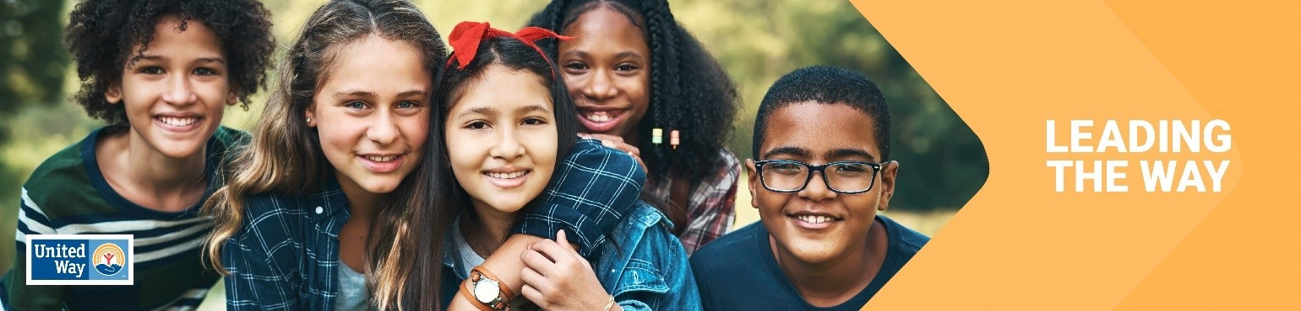
Good [Morning/Afternoon COMPANY] Team,

Donors like you and me are the heart of United Way. When we give, we give more than just dollars. We give hope, solutions and a chance at a brighter future.

United Way of Northern Arizona funds and supports dozens of organizations and programs that are making the biggest impact in the community. When you give, you support multiple causes, making your dollars go further and creating a bigger impact.

We’re [$$$ *OR %%%] away from our goal of [$$$ OR %%% participation]. I hope you’ll support our [COMPANY] United Way Campaign before [DATE] to help us end our campaign strong!

Thank you,
[COORDINATOR SIGNATURE & INFO]

*********************************

Last chance email

[Subject line] Still Time to Lead the Way

Good [Morning/Afternoon COMPANY] Team,

Over the last few weeks, we’ve witnessed the kindness and generosity of our [COMPANY] team. We’re amazed by your enthusiasm to show up and willingness to help others in our community.

We have done such a great job of Leading the Way through our [COMPANY] United Way campaign! Thank you for your generosity and support for our community, helping to raise [$$$] as of [DATE].

If you haven’t made your gift yet, there’s still time but make sure to do it soon, as our campaign ends on [DATE].

If you have any questions on how to give, please contact me today.

[COORDINATOR SIGNATURE & INFO]

Email 4: General Thank You #1
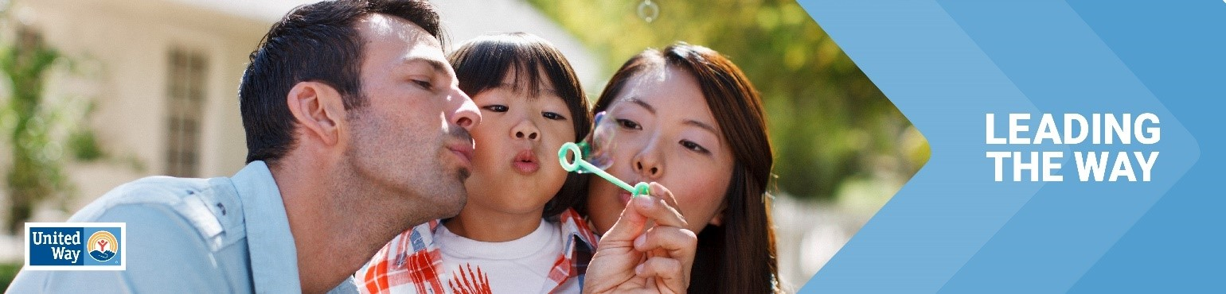
Click here for the Canva template

Subject Line: Thank you for Leading the Way in Northern Arizona
Preheader Text: [intentionally left blank]
Email Body:

Dear [Name],

Join me in celebrating the success of [Company Name’s] efforts to Lead the Way by changing lives in Northern Arizona

I’m thrilled to report: [customize]

[Company Name] employees gave $ [dollars pledged] to United Way of Northern Arizona
[participation rate%] of [Company Name] Employees gave to United Way of Northern Arizona
[number of donors] of [Company Name] employees gave to United Way of Northern Arizona
[Company Name] employees contributed more than [number of volunteer hours] volunteer hours during the campaign.

Together, our collective impact is creating a better future for youth, families and communities in northern Arizona. Thank you for Leading the Way!
[Closing],
Signature

Email Donor Thank You #2
Image: Use below, select one of your own images
Click here for the Canva template

Subject Line: Thank you for Leading the Way in northern Arizona
Preheader Text: [intentionally left blank]
Email Body:
Dear [Name],
First, thank you for Leading the Way in northern Arizona through your generous gift to United Way. Your donation is making a real difference in the lives of our neighbors and friends.
Today and every day, we need you with us. Here are ways that your support can continue making our community a better place:

  - Volunteer: Make a difference by volunteering – providing meals to someone who’s homebound, reading to preschoolers to get them school-ready, or passing out food to neighbors in need. Consider serving on one of our community’s grant evaluation boards or offering your unique skills to a local nonprofit who needs your expertise.
  - Advocate: Encourage your neighbors and colleagues to become active in our community and raise your voice on the issues that impact hard-working families in northern Arizona Join United Way’s in-person and virtual events to help every person in our region thrive.
  - Stay in the Loop: Signup for our email newsletter to keep informed about what’s going on across northern Arizona
Thank you for your commitment to the United Way of Northern Arizona Together, let’s Lead the Way to a better future for all.
[Closing],
Signature

