**Post 1:**

United Way of Northern Arizona is ‘Leading the Way’ with bold solutions to step up for our youth and our communities in Coconino, Navajo, and Apache counties.

UWNA brings people in the community together to tackle the big challenges in our region, from

early childhood development and positive youth development to meeting the basic needs for safety and security for all who call northern Arizona home. 🏠

With support from all of us, we can direct resources swiftly and efficiently to where they're needed most. ⏩

I’m a supporter of UWNA’s annual campaign, and I’d love for you to join me!

Together, we can Lead the Way to a brighter future for all. 🔆

<https://andar.nazunitedway.org/comm/SinglePageRegPledge.jsp?SA=305813>

#LeadingTheWay #StrongerTogether #NorthernArizonaCommunity #StepUpForYouth

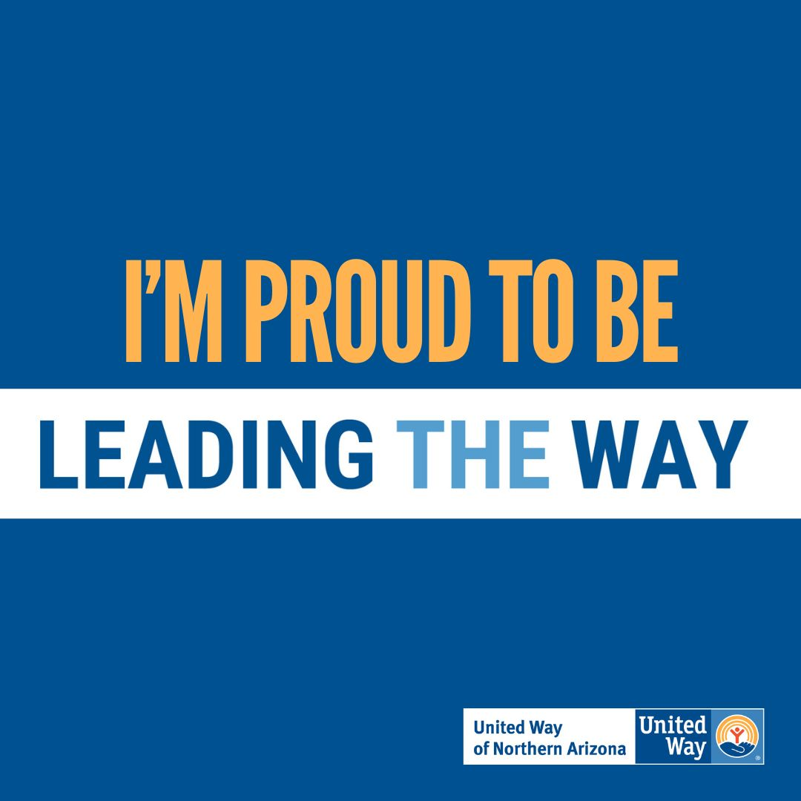

**Post 2:**

United Way of Northern Arizona’s 2024-2025 annual campaign is going on now! ✨

It’s all about Leading the Way to a better future. Leading the Way for better access to early childhood development programs. 🧠 Leading the Way in promoting strong, resilient youth. 💪

Leading the way so the basic needs for safety and security are met by all who call Coconino, Navajo, or Apache County home. 🏠

I’m a supporter of UWNA and I’d love for you to join me, too!

Together we lead the way and step up for our youth and our communities.

Click below to donate today and Thank You! <https://andar.nazunitedway.org/comm/SinglePageRegPledge.jsp?SA=305813>

#LeadingTheWay #StrongerCommunity #StepUpForYouth

