# WORKPLACE CAMPAIGN EMAIL SEQUENCE

Below are a few email templates to help your Campaign Coordinator communicate with your employees. Please modify them to fit your workplace.

EMAIL 1A

**CEO Email Prior to Kickoff**

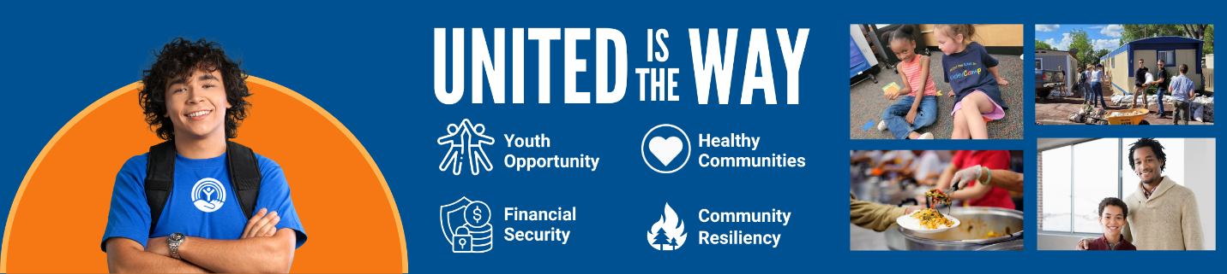

[Subject Line]

United is the Way

Dear team,

At [COMPANY NAME], we know that **United is the Way** to create and sustain communities where everyone can thrive. When we work together, we ensure a better future for all our friends and neighbors in northern Arizona.

United Way of Northern Arizona works to bring together people and resources to achieve bold goals and collaboratively tackle our region’s biggest challenges.

When you give your dollars or time, you help fund programs that promote:

* Youth Opportunity. Through initiatives that *Step Up for Youth*, we can expand access to affordable childcare; foster early childhood development; and address the mental wellbeing of our adolescents and teens.
* Financial Security. Contributing to United Way of Northern Arizona fuels programs that provide education, tools, and workforce development that help give families financial peace of mind.
* Healthy Communities. Helping families meet basic needs like safe housing and adequate food enables them to move from day-to-day existence to planning for a more positive future.
* Community Resiliency. Your contribution to the United Way of Northern Arizona supports its efforts to marshal volunteers and resources in times of emergency, such as wildfires and floods.

Learn more about the work of United Way of Northern Arizona by visiting www.nazunited.org.

We invite you to attend our campaign kick-off meeting on [DATE] at [LOCATION] to learn more about our giving campaign and how the work of United Way makes an impact in our community.

If you have any questions any time throughout the campaign, please reach out to [Campaign Coordinator NAME + EMAIL].

Thank you!

[CEO NAME]

*************************

[Subject Line] United Way Campaign Launch: United is the Way

Hello [COMPANY] Employees!

Today, we come together to kick off our [COMPANY] United Way campaign. TOGETHER we can improve the lives of children, families and individuals throughout Coconino, Navajo, and Apache counties.

Join us at our [EVENT – POTLUCK, ICE CREAM SOCIAL, ETC.] today in [LOCATION: ONLINE / IN-PERSON] at [TIME] to learn about our partnership with United Way and what that means for northern Arizona.

See you there!

[COORDINATOR SIGNATURE AND CONTACT INFO]

****************************************

EMAIL 1B

[Subject Line] Acting Today for a Better Tomorrow

Good [Morning/Afternoon COMPANY] Team,

United Way of Northern Arizona mobilizes our community, so our youth are supported from cradle to career, and families are helped in times of crisis.

They work with our community, corporate, and nonprofit partners to achieve bold goals for northern Arizona. Your support goes to the most effective programs supporting our neighbors.

With your continued support, we will:

• Feed those facing food insecurity

• House those experiencing homelessness

• Help students stay in school

• Prepare youth for success in school, work and life

• Support emergency shelters and homelessness prevention

• Connect those in financial distress with resources to pay bills and stay in their homes

and so much more!

As a reminder, our United Way campaign kicked off on [DAY OF WEEK & DATE]. Our goal is to [raise $$$ OR reach %%% participation] by the end of our campaign on [DATE].

Feel free to reach out to me with any questions about your donation, or to seek out volunteer opportunities!

[COORDINATOR SIGNATURE AND CONTACT INFO]

*****************************

EMAIL 2

[Subject Line] It’s Up to Us! United is the Way

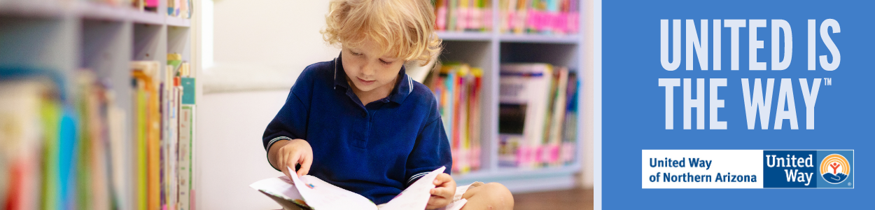

Good [Morning/Afternoon COMPANY] Team,

United is the Way to breaking down barriers and innovative solutions.

Our [COMPANY] United Way campaign is an essential part of those efforts. Together, we play a role in bringing about positive changes for our neighbors. Your contribution to this campaign helps United Way continue to promote:

* Early Childhood Development through greater access to high-quality, affordable preschools; literacy programs like the Dolly Parton Imagination Library; and KinderCamp™ to prepare children with little to no preschool experience.
* Positive Youth Development and efforts to address issues like youth mental wellbeing.
* Safety and Security for all who live in Coconino, Navajo, and Apache counties.

We are [$$$ *OR %%%] away from our goal of [$$$ *OR %%% participation] by the end of our campaign on [DATE].

Feel free to reach out to me with any questions!

[COORDINATOR SIGNATURE AND CONTACT INFO]

************************************

EMAIL 3

[Subject Line] Your Donation Makes a Difference!

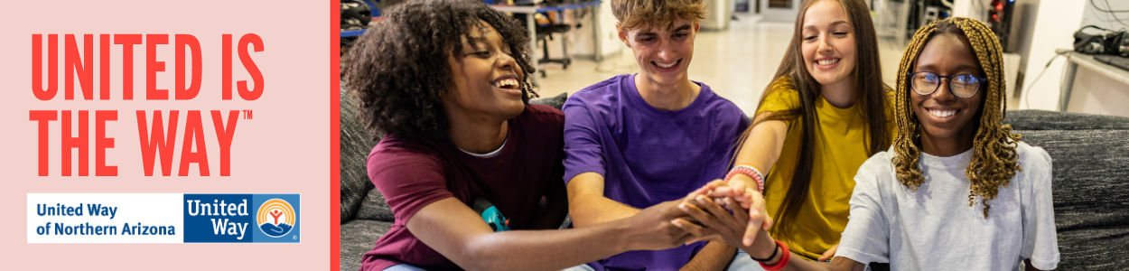

Good [Morning/Afternoon COMPANY] Team,

Donors like you and me are the heart of United Way. When we give, we give more than just dollars. We give hope, solutions, and a chance at a brighter future.

United Way of Northern Arizona funds and supports dozens of organizations and programs that are making the biggest impact in the community. When you give, you support multiple causes, making your dollars go further and creating a bigger impact.

We’re [$$$ *OR %%%] away from our goal of [$$$ OR %%% participation]. I hope you’ll support our [COMPANY] United Way Campaign before [DATE] to help us end our campaign strong!

Thank you,

[COORDINATOR SIGNATURE & INFO]

*********************************

**Last chance email**

[Subject line] Still Time to Live United

Good [Morning/Afternoon COMPANY] Team,

Over the last few weeks, we’ve witnessed the kindness and generosity of our [COMPANY] team. We’re amazed by your enthusiasm to show up and willingness to help others in our community.

We have done such a great job of showing that United is the Way through our [COMPANY] United Way campaign! Thank you for your generosity and support for our community, helping to raise [$$$] as of [DATE].

If you haven’t made your gift yet, there’s still time but make sure to do it soon, as our campaign ends on [DATE].

If you have any questions on how to give, please contact me today.

[COORDINATOR SIGNATURE & INFO]

**Email 4: General Thank You #1**

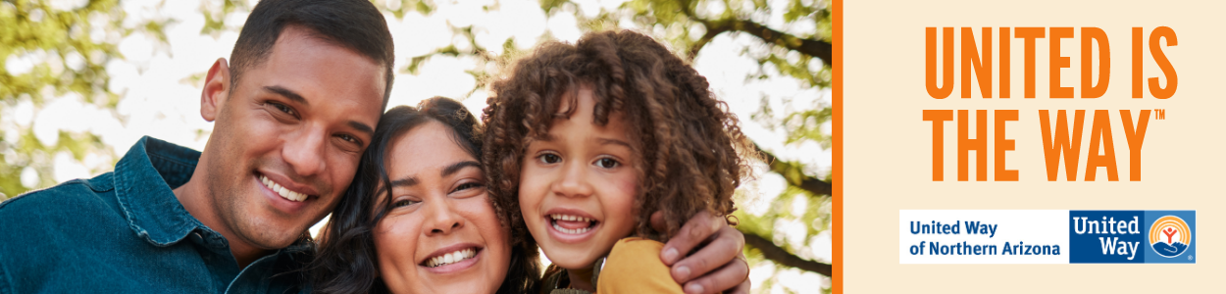  
*Click* [*here*](https://www.canva.com/design/DAGFc7D572w/HYfQvy-UpDF-vc3gLkL57Q/view?utm_content=DAGFc7D572w&utm_campaign=designshare&utm_medium=link&utm_source=publishsharelink&mode=preview) *for the Canva template*

**Subject Line:** Thank you for your United Way donation

**Preheader Text:** [intentionally left blank]

**Email Body:**

Dear [Name],

Join me in celebrating the success of [Company Name’s] efforts to change lives in Northern Arizona

I’m thrilled to report: [customize]

[Company Name] employees gave $ [dollars pledged] to United Way of Northern Arizona

[participation rate%] of [Company Name] Employees gave to United Way of Northern Arizona

[number of donors] of [Company Name] employees gave to United Way of Northern Arizona

[Company Name] employees contributed more than [number of volunteer hours] volunteer hours during the campaign.

Together, our collective impact is creating a better future for youth, families and communities in northern Arizona. Thank you for showing that United is the Way!

[Closing],  
*Signature*

**Email Donor Thank You #2**

**Image**: Use below, select one of your own images

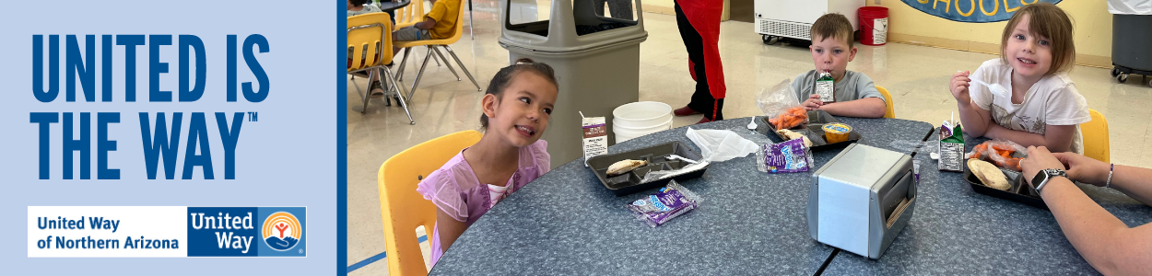  
*Click* [*here*](https://www.canva.com/design/DAGFc7D572w/HYfQvy-UpDF-vc3gLkL57Q/view?utm_content=DAGFc7D572w&utm_campaign=designshare&utm_medium=link&utm_source=publishsharelink&mode=preview) *for the Canva template*

**Subject Line:** Thank you for Living United in northern Arizona

**Preheader Text:** [intentionally left blank]

**Email Body:**

Dear [Name],

First, thank you for your generous gift to United Way of Northern Arizona (UWNA). Your donation is making a real difference in the lives of our neighbors and friends.  
  
Today and every day, we need you with us. Here are ways that your support can continue making our community a better place:

* + **Volunteer**: Make a difference by volunteering – providing meals to someone who’s homebound, reading to preschoolers to get them school-ready, or passing out food to neighbors in need. Consider serving on one of our community’s grant evaluation boards or offering your unique skills to a local nonprofit who needs your expertise.
  + **Advocate**: Encourage your neighbors and colleagues to become active in our community and raise your voice on the issues that impact hard-working families in northern Arizona Join United Way’s in-person and virtual events to help every person in our region thrive.
  + **Stay in the Loop:** Signup for UWNA’s email newsletter to keep informed about what’s going on across northern Arizona. Just email [uwna@nazunitedway.org](mailto:uwna@nazunitedway.org) and let them know you want to subscribe.

Thank you for your commitment to the United Way of Northern Arizona Together, we’re showing that United is the Way to a better future for all.

[Closing],  
*Signature*